* -: In the last lecture, we parameterized our first Pipe here, the DatePipe.
* Now let's learn more about all the built-in Pipes and how we can configure them.
* The place to learn more is the official documentation.
* So you can just head to : <https://angular.io/>
* io, and there under Docs, click on API Reference.

<https://angular.io/api>

* Now, you may ignore the version number up here.
* It should be four point something when at the point of time you view the video.
* I'm just recording this in advance, but the Pipes won't change or haven't changed.
* So here you can enter "Pipe" as a filter, and then you view all the Pipes, which are built into Angular.
* And there, you see, we got a couple of them.

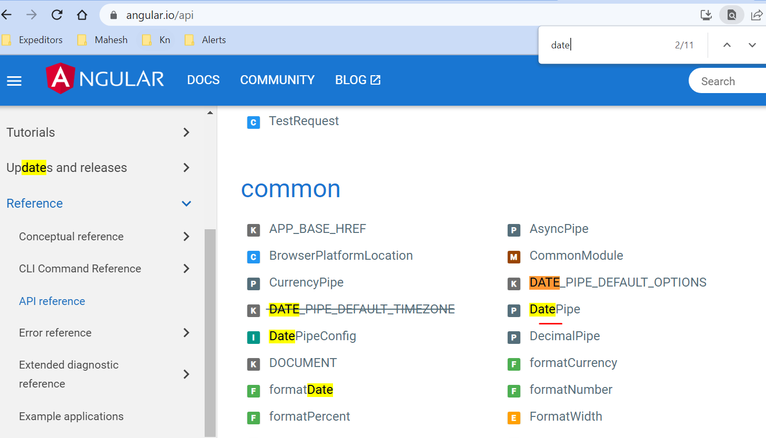

* We already use the DatePipe and the UpperCasePipe, but there also is a SlicePipe which allows you to take a slice of the input.
* And there you would see that the SlicePipe actually takes multiple arguments to start and to end.

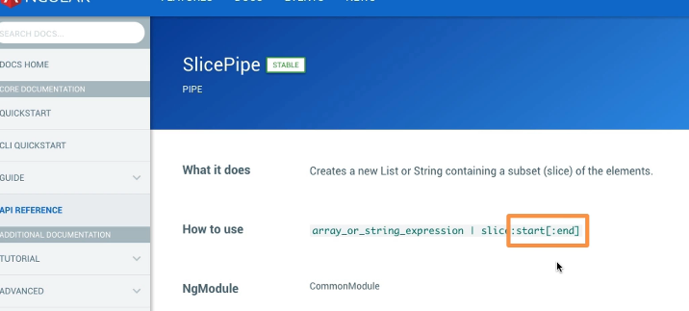

* So where it should start slicing out a piece of the word and where it should end.
* There you can also view a detailed explanation and an example.
* So this is really a great place to dive into Pipes and play around with them, since there is not much sense in covering them all in detail here video by video as they are very specific in the use case.
* Anti documentation here is really great for diving deeper into it.
* So with that out of the way, I want to have a look at the DatePipe.

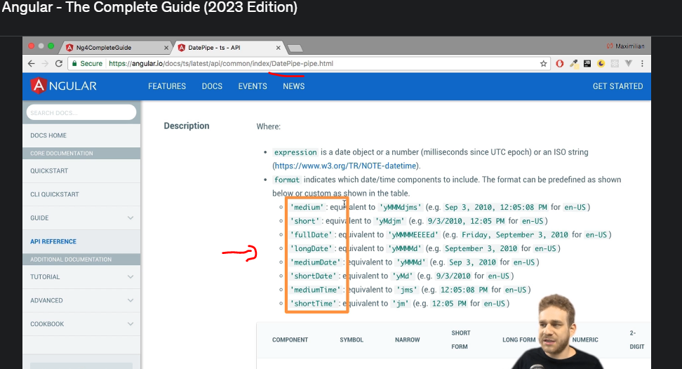

* Here you can see how you can configure it.
* You can see a couple of different shortcuts for getting a specific date format, or you can format it from scratch with the typical symbols like lowercase "d" for a day, and so on.
* So this is where you can dive into how to make the date look exactly how you want it to look.
* Now with that, let's move on to creating our own Pipe or almost move to that point.
* One other thing, and then we will move on.